Note: This document is “view only”. Please create a copy of this document and save it to your drive.

**SOP- Project & Task Management- Systems Vault**

**PREREQUISITES**

[SOP MASTER- Client Offboarding- Systems Vault](https://docs.google.com/document/d/1TUsxDcBOHWXnBeqWgS1kc_VazIBegKJf3Ob4nw4jYnk/edit?usp=sharing)

[Teamwork PM](https://sarahnoked.teamwork.com)

**PURPOSE**We create, organize, monitor, comment on, and mark complete all tasks in [Teamwork PM](https://sarahnoked.teamwork.com) in order to have one central workplace where all our projects are managed

**POLICY**

Each project has a Project Manager assigned (and indicated in the project name) who is responsible for ensuring that all tasks are handled properly and according to this SOP.

Only the Project Manager is responsible for making one-off tasks as complete and assigning follow up tasks. This is so that the Project Manager can assign and take needed action for follow up.

When you are assigned a recurring task and are not the Project Manager of a project you can mark tasks off as complete.

All team members have permission to assign tasks and all tasks assigned must be assigned to someone and must have a due date.

**PARTY**

All Team Members

**PROPERTY**

Online Business Manager

**PROCESS**Part 1: Creating Tasks

Part 2: Creating a Task List from a Template

Part 3: Managing Tasks

Part 4: Commenting on Tasks

Part 5: Marking Tasks as Complete

**PROCEDURE  
Part 1: Creating Tasks**  
 1. Login to [Teamwork PM](https://sarahnoked.teamwork.com)

2. Navigate to the correct project

4. From within the task list click on to create the task

1. Assign the person responsible. Tasks can be assigned to multiple people, but should only be assigned to one person. The project manager is responsible for following up on ALL outstanding tasks.
   1. Assign a start and due date. **All tasks must have a due date (even if is just tentative)**
   2. Check ‘Notify by email’
   3. If the task is recurring click on 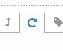and indicate how often the task recurs. It is imperative that if a task is recurring it is set up as such, otherwise once completed it will no longer show up on the list
   4. If the task is dependent on another task click on 
   5. If the task has subtasks click on 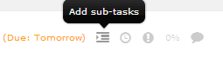

5. Attach any relevant files and links to google drive folders in the task comments or description

**Part 2: Creating a Task List from a Template**

1. Select the Project by name you are adding the task template to
2. Click on ‘Tasks’ from the main menu



1. Add a task list by clicking on the green button on the right “Add a task list”
2. Click on ‘Advanced’

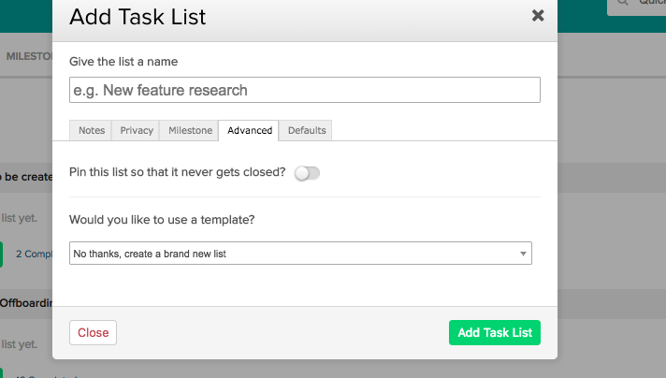

1. Click on the arrow to the left of the task list name. Hover over Templates and select ‘Add tasks from template’, select the template you need and press ‘Apply template’
2. Assign tasks and due dates for all tasks.

**Part 3: Managing Tasks**

1. Each Project Manager is responsible for reviewing, following up and ensuring any people assigned to tasks on projects are fulfilling their responsibilities:
   1. All completed tasks are marked as complete
   2. All task lists are up to date
   3. No tasks are overdue

**Part 4: Commenting on Tasks**

1. Login to [Teamwork](https://sarahnoked.teamwork.com)
2. Navigate to the task you would like to add a comment on.
3. In the comments section, include additional details and attach any additional files or links to Google Drive
4. Check ‘Notify by email’ and select the people who need to be notified. Once you’ve included the details click



**Part 5: Marking Tasks as Complete**

1. If you are the Project Manager:
   1. Review task and make sure it is 100% complete
   2. Mark Complete
2. If you are NOT the Project Manager:
   1. Review task and make sure it is 100% complete
   2. Ping the Project Manager, by commenting on the task, for follow up. If necessary, reassign the task to the Project Manager.

**Created by:**

**Department:** Growth

**Date:**

**Revised:**

**Revised by:**